Setup: Employees Table
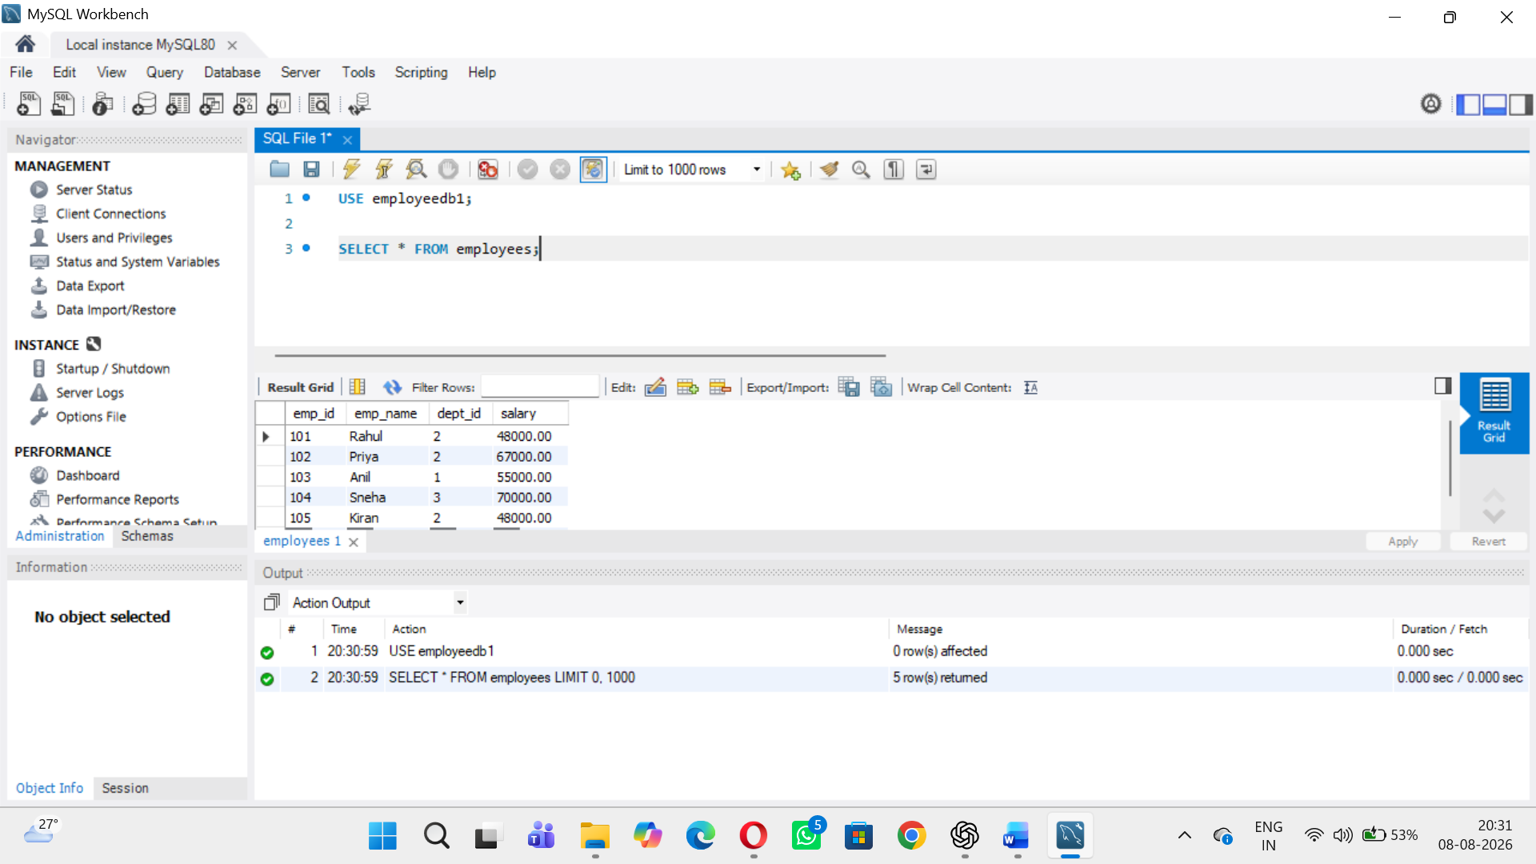

Verify Data.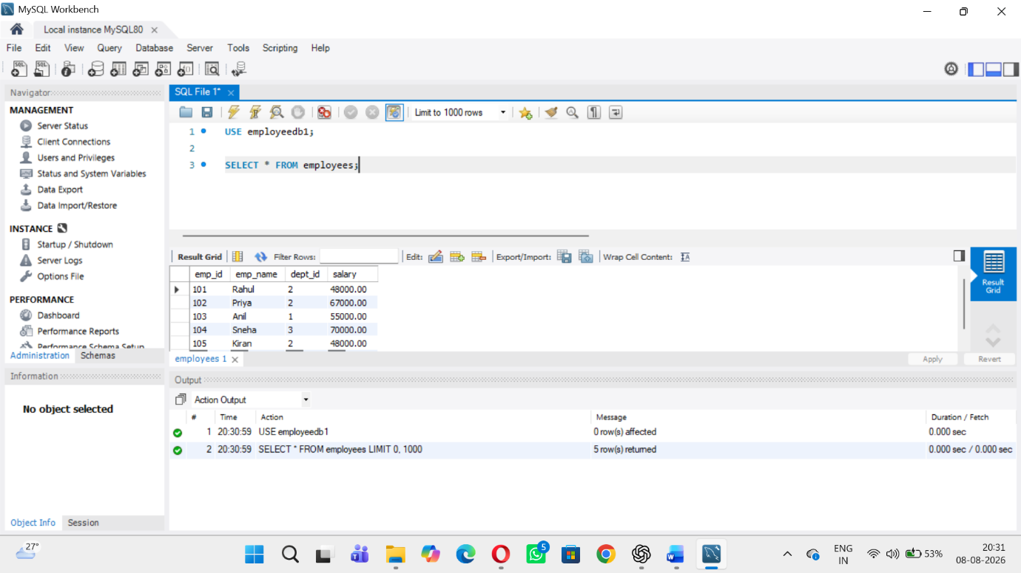

3.Procedure 1 – Display All Employees
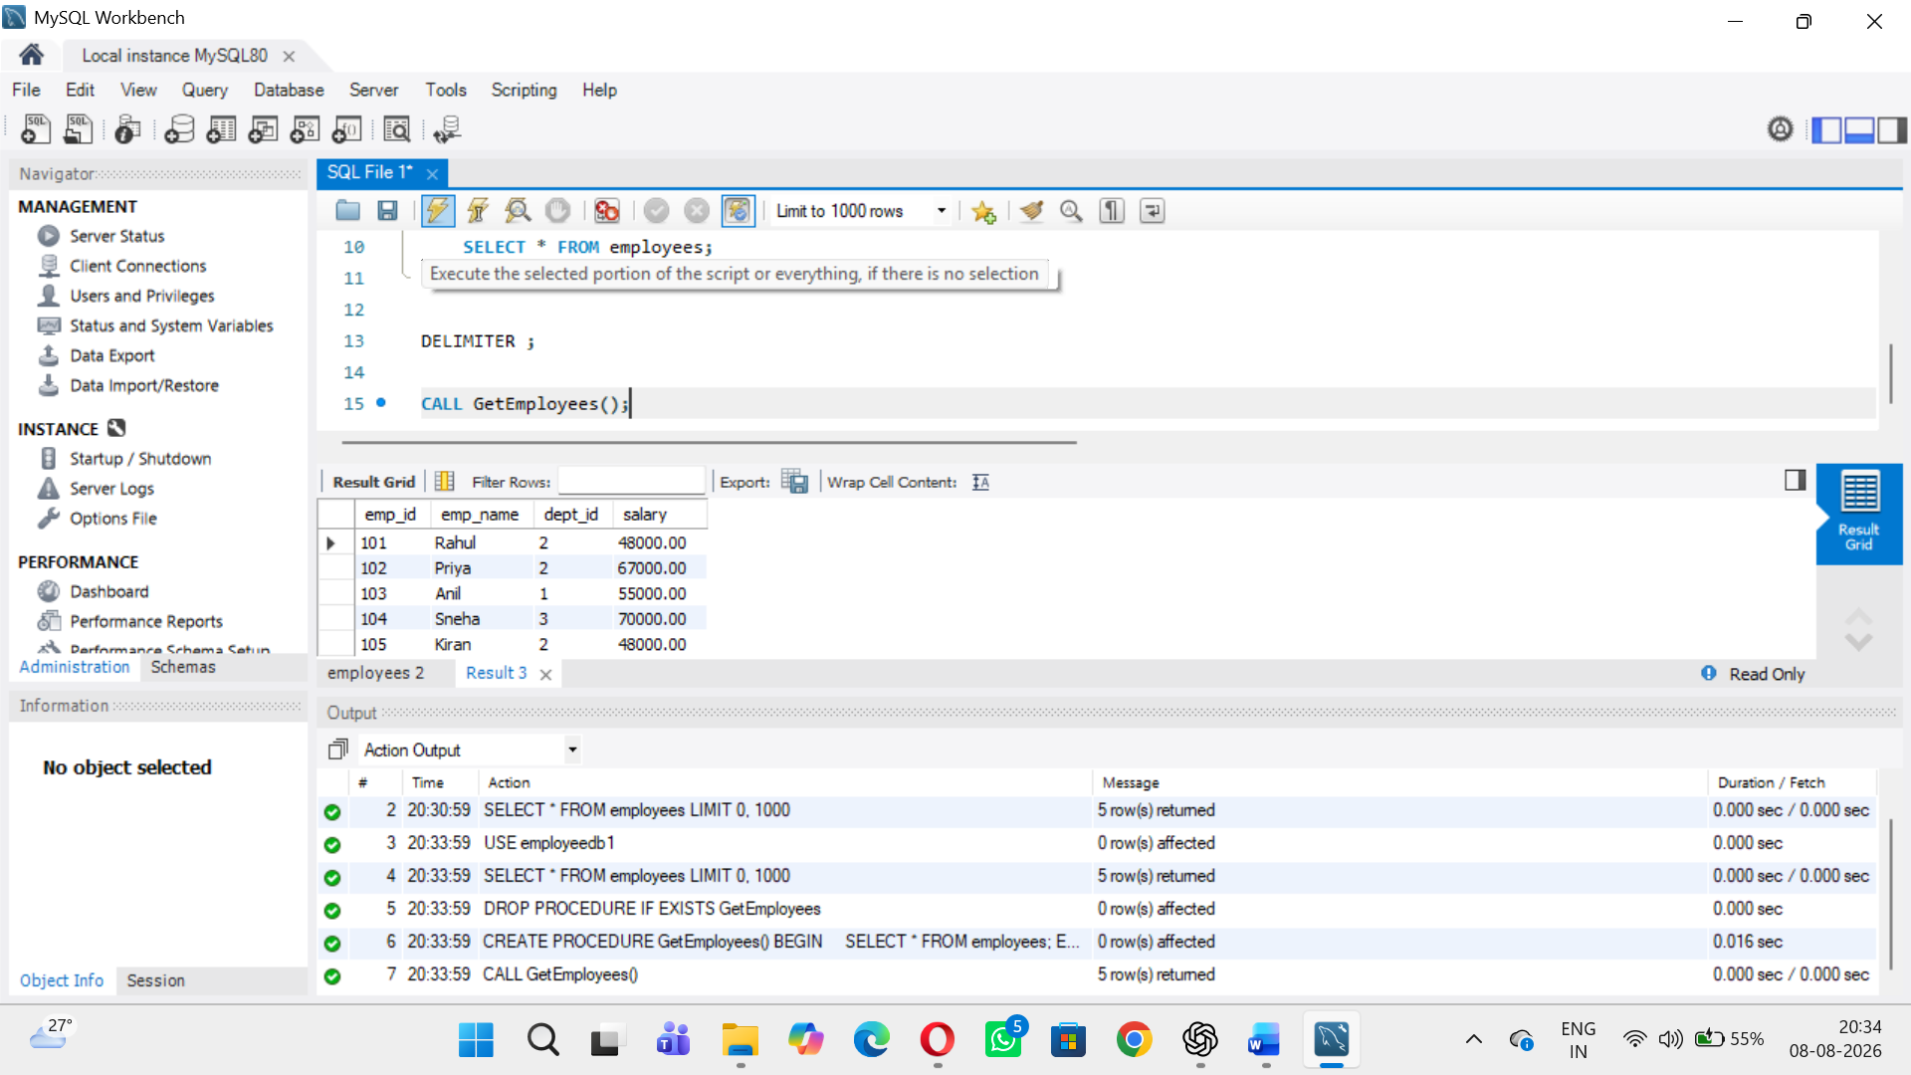

Procedure 2 – IN Parameter
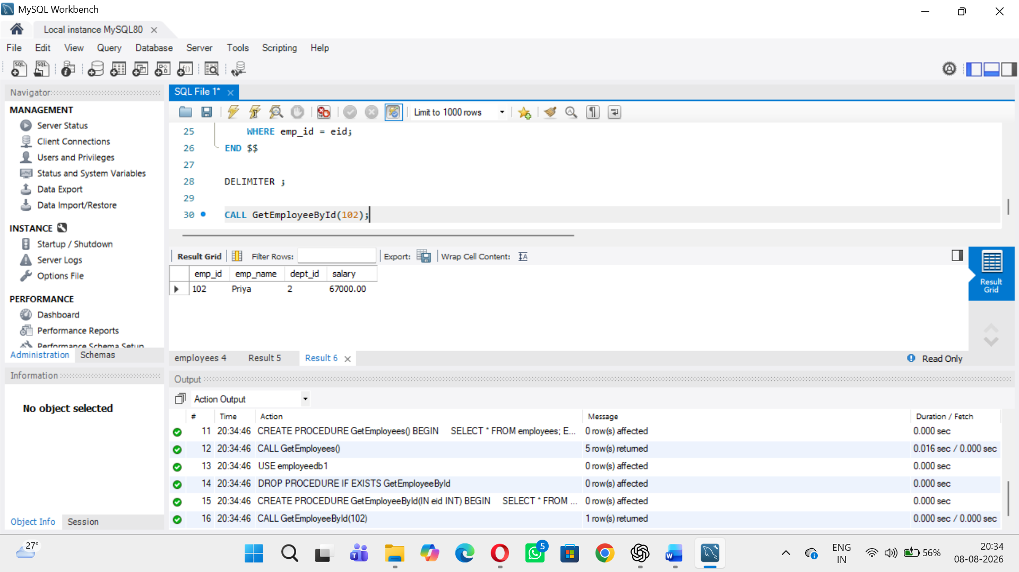

Procedure 3 – Update Salary
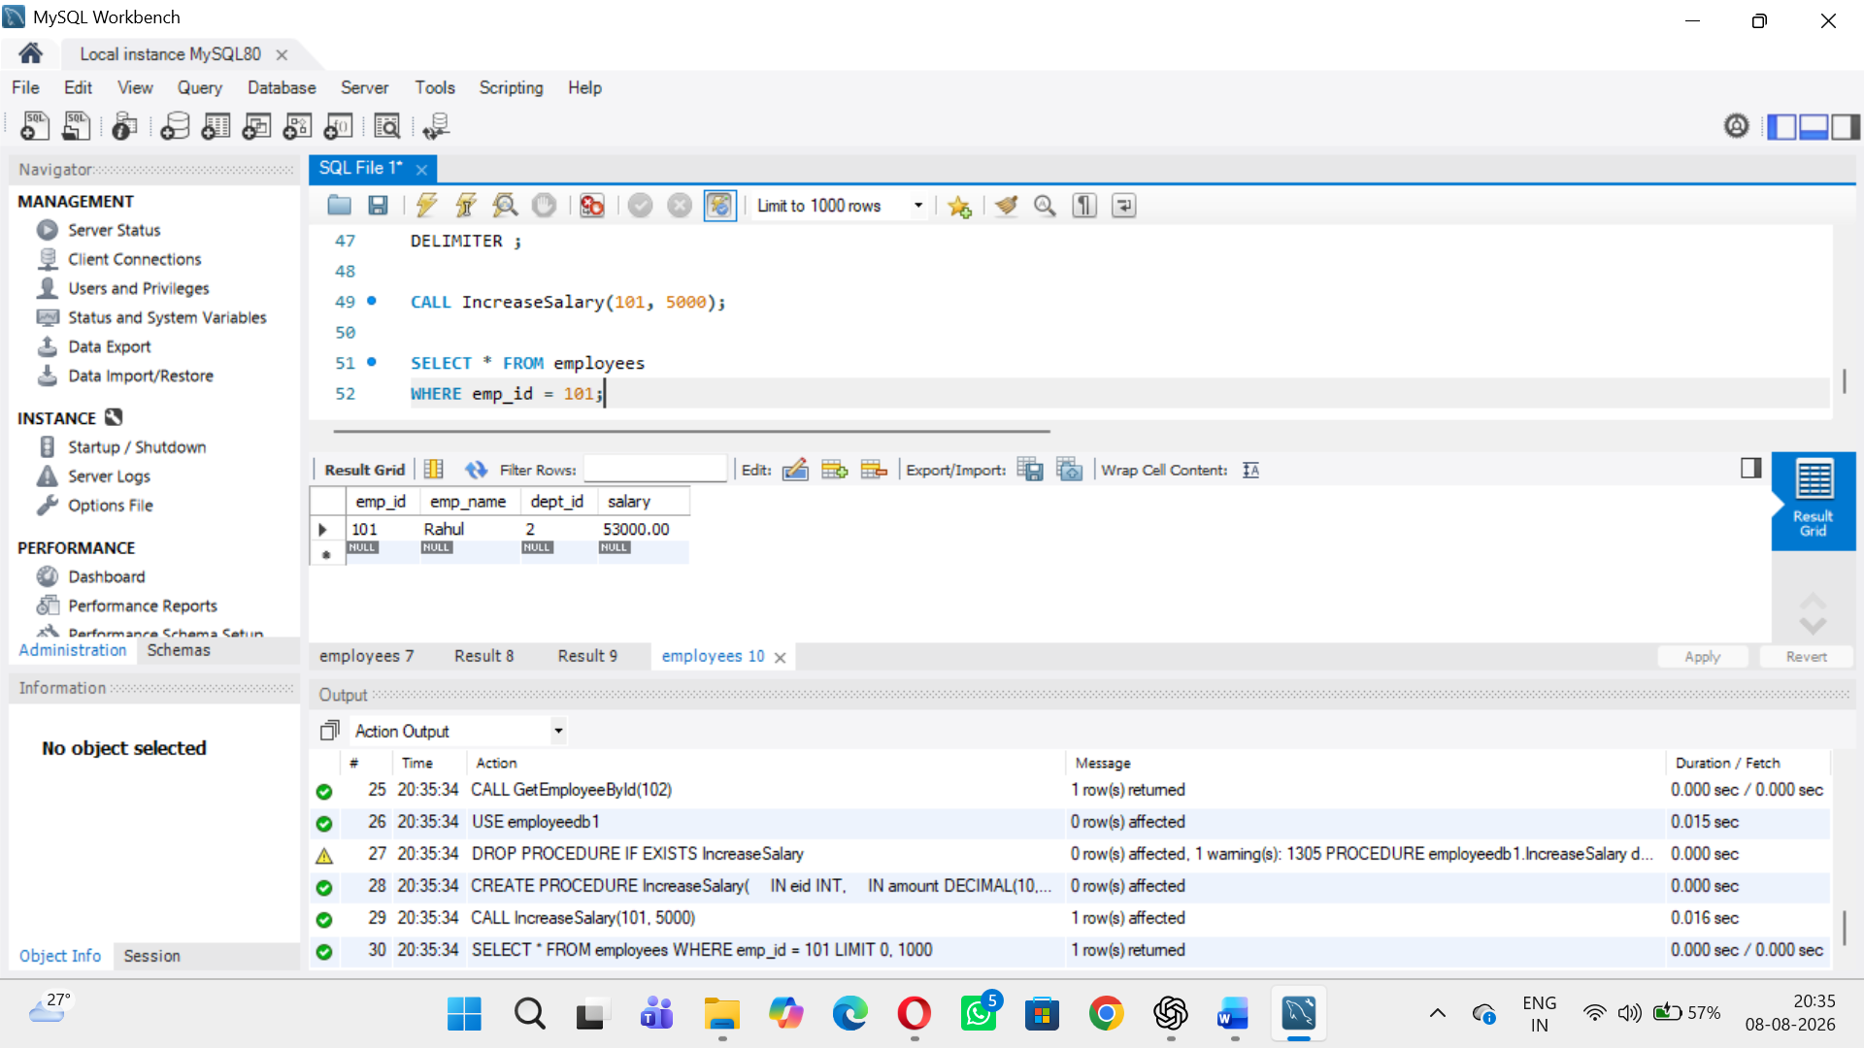

Procedure 4 – Aggregate Function
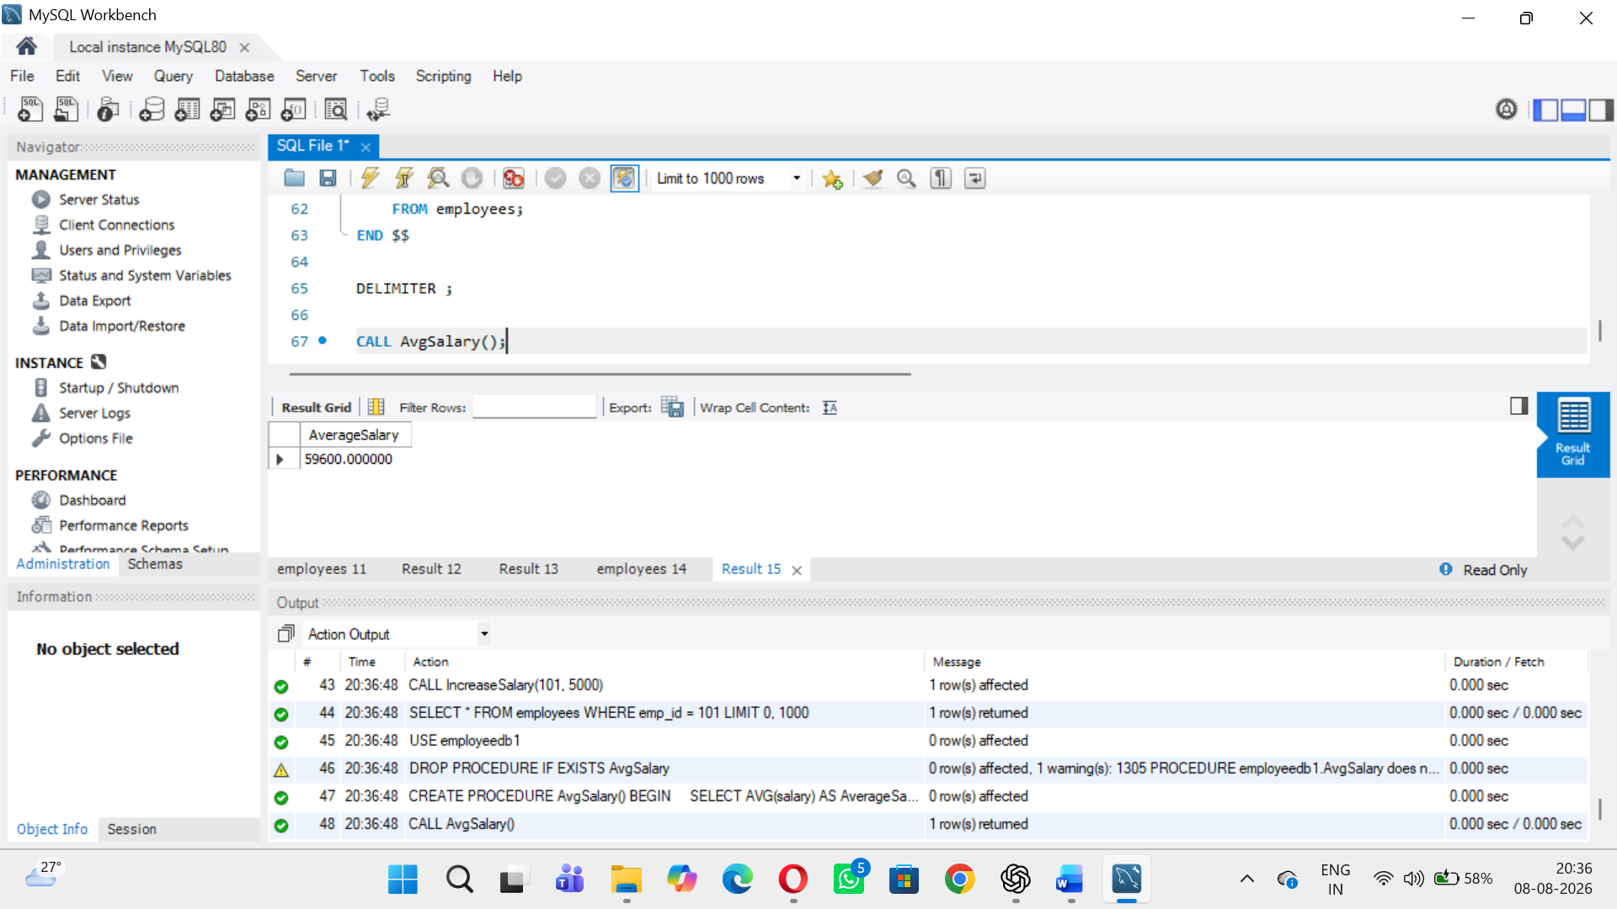

Procedure 5 – JOIN
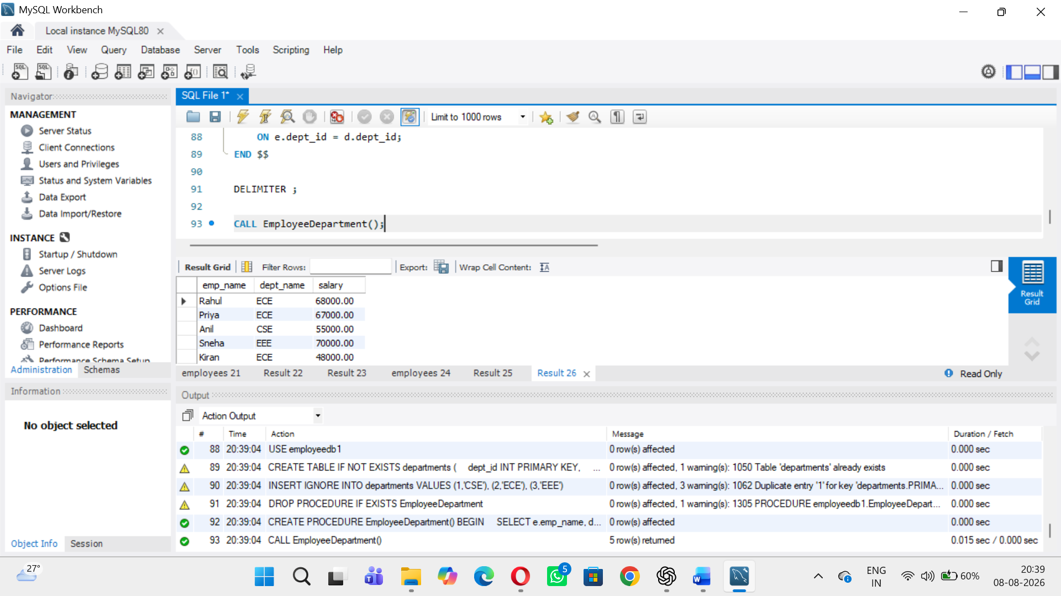

Procedure 6 – GROUP BY and AVG
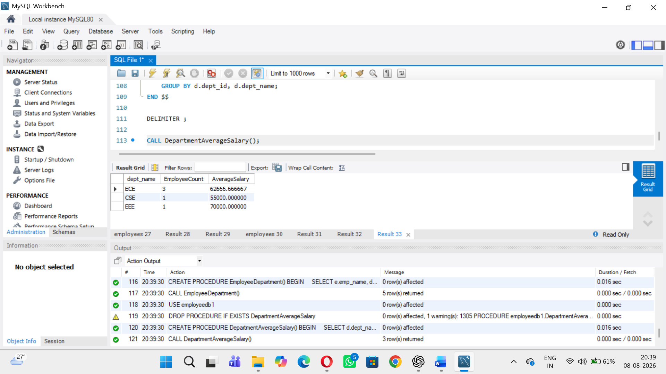

Procedure 7 – IF...ELSE
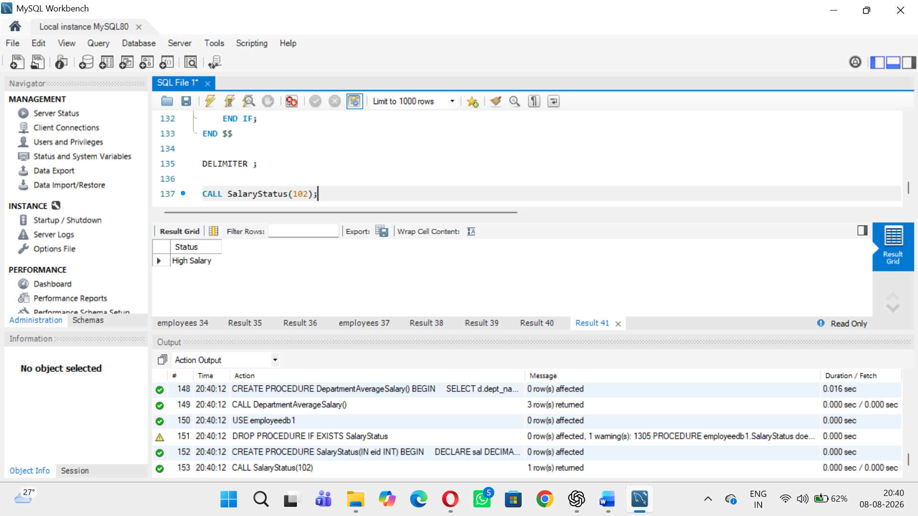

Procedure 8 – OUT Parameter
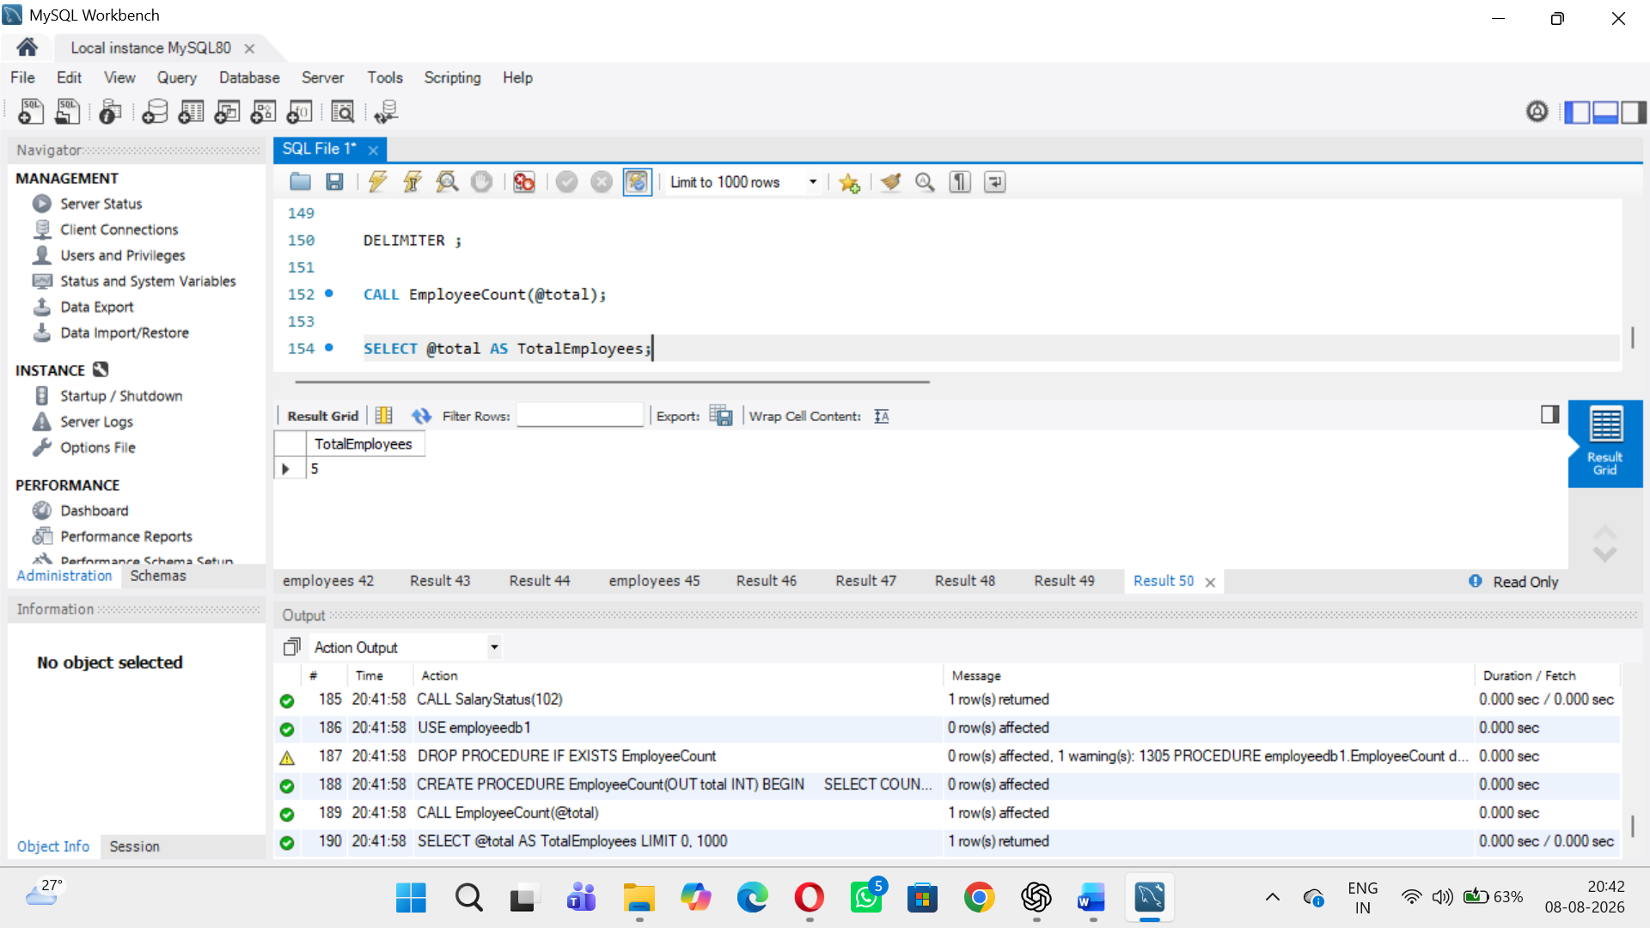

Procedure 9 – INOUT Parameter
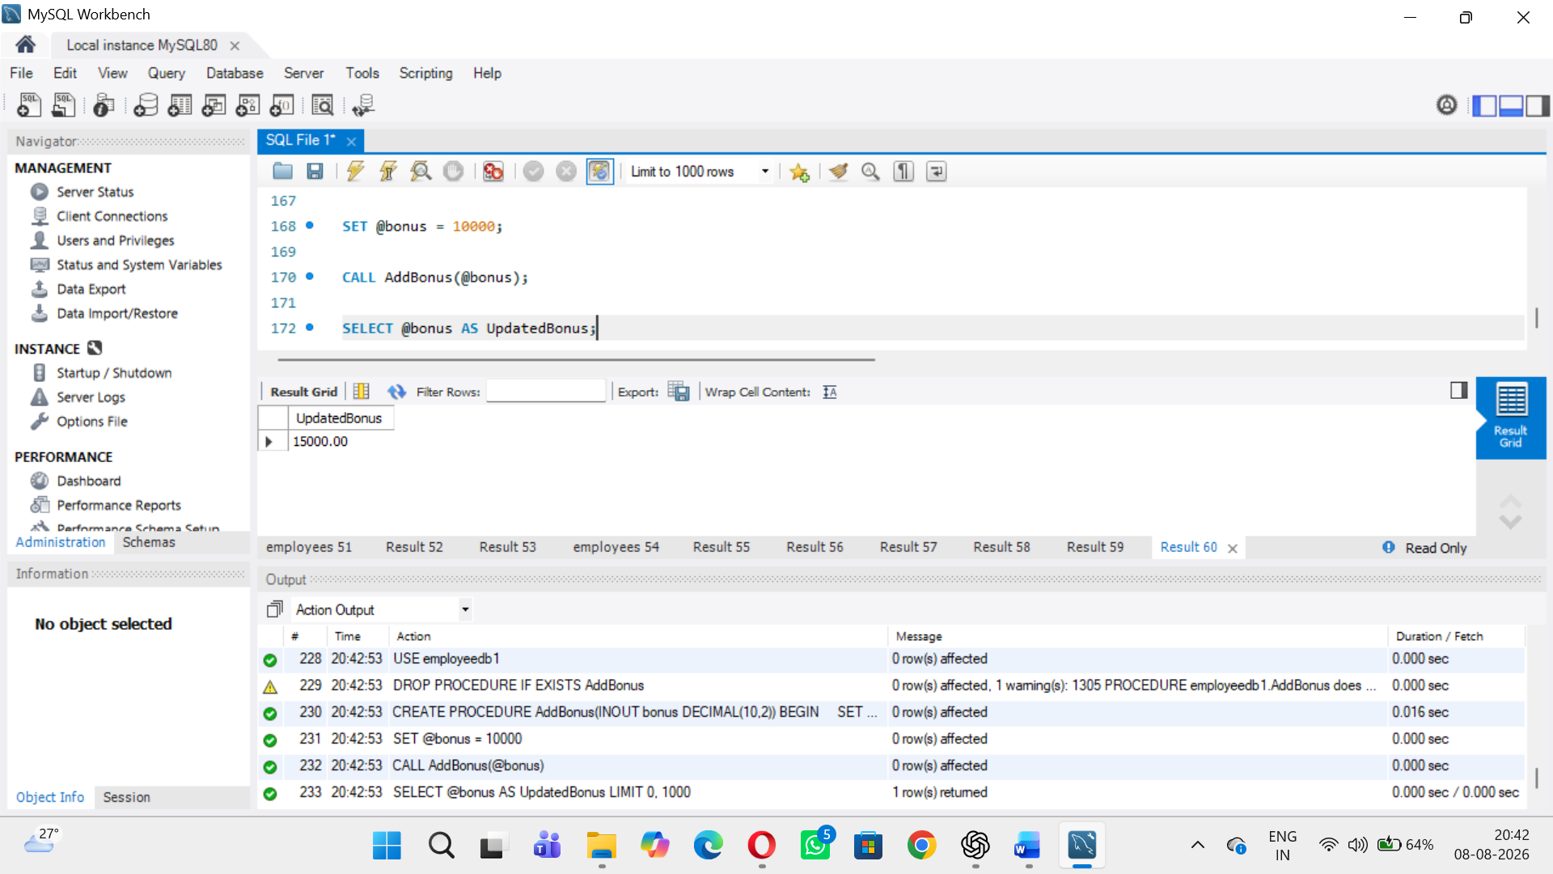

Procedure 10 – Transaction
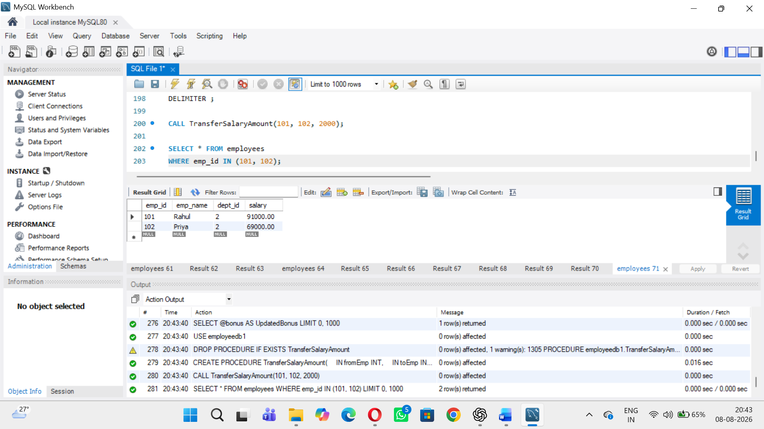

- Create a procedure to display employees whose salary is greater than a given amount.
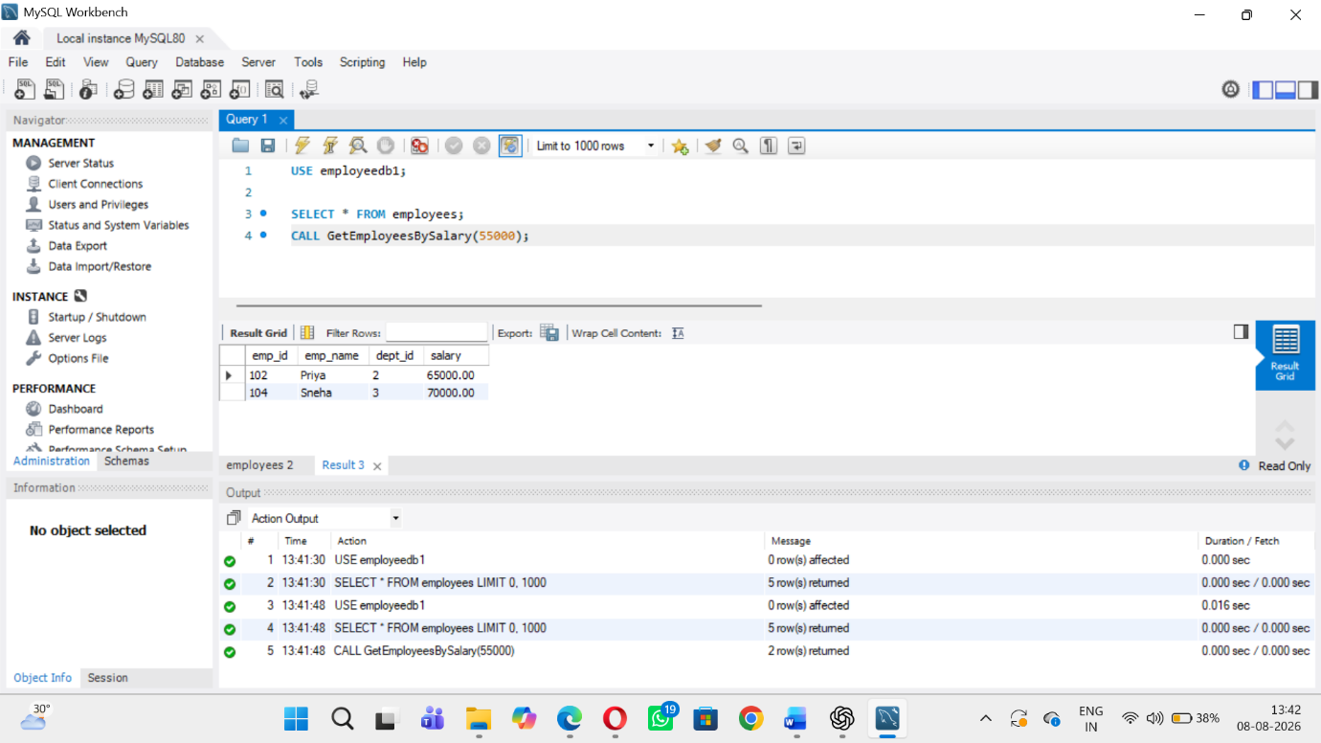
2 Create a procedure to update an employee's department using IN parameters.
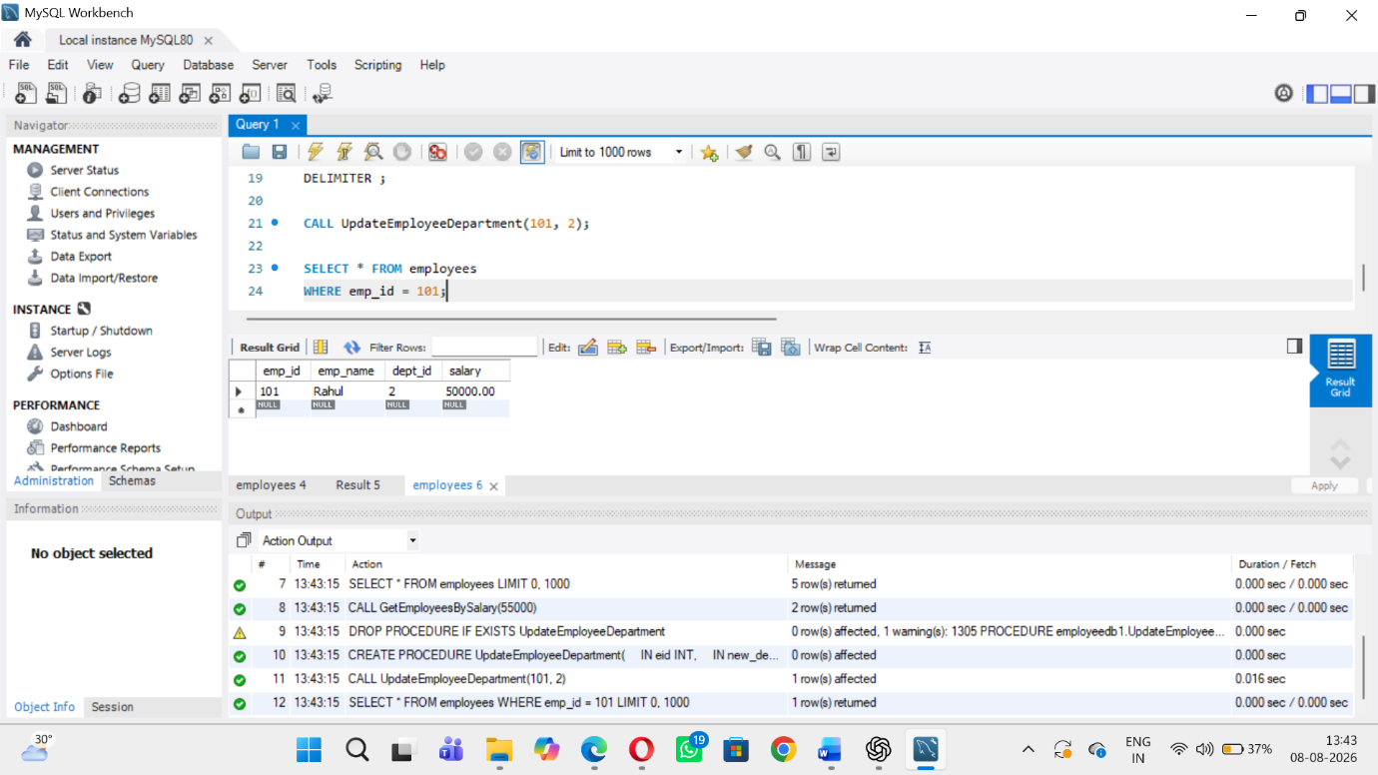

3 Create a procedure to return the maximum salary using an OUT parameter
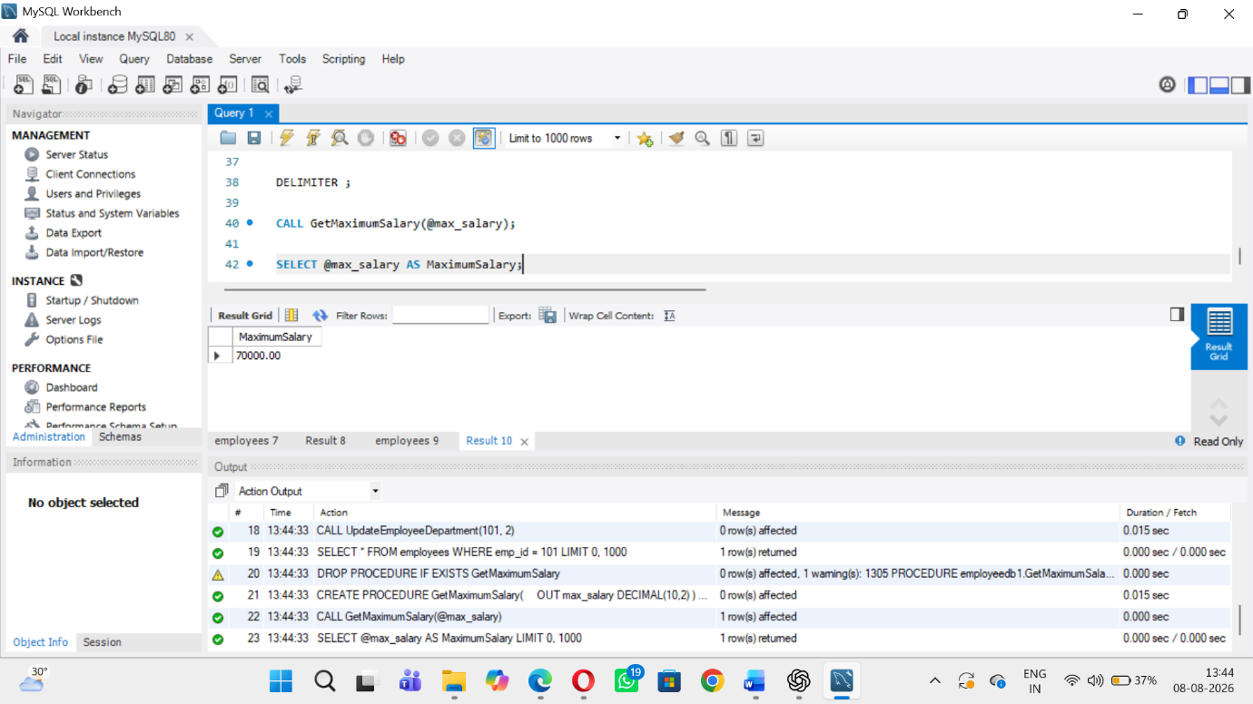
4. Create a procedure to return the employee count of a specified department.
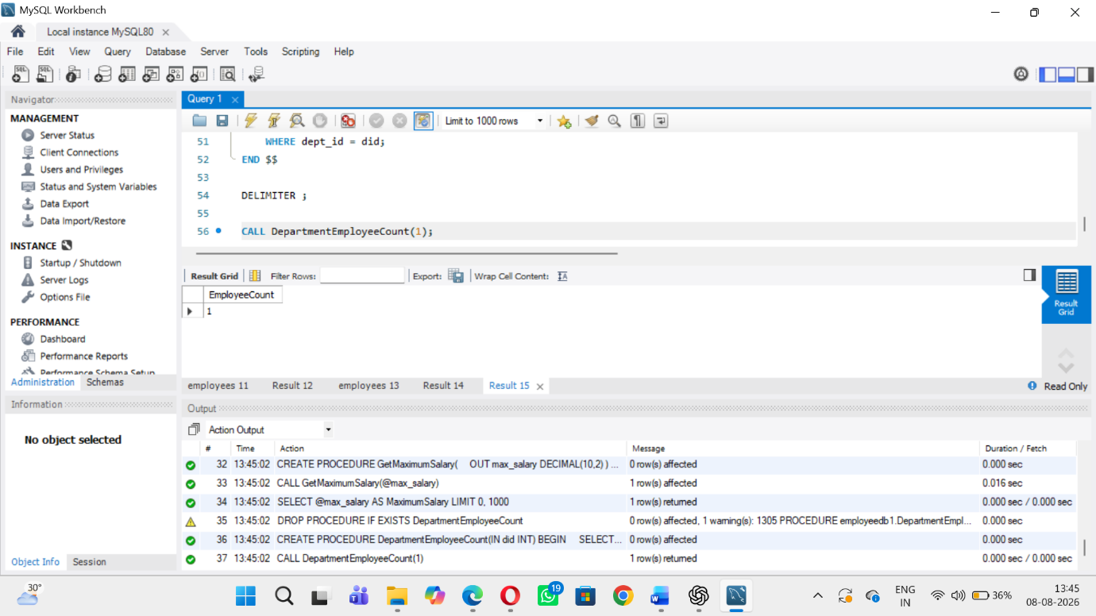
5. Create a procedure using JOIN to display employee and department details.
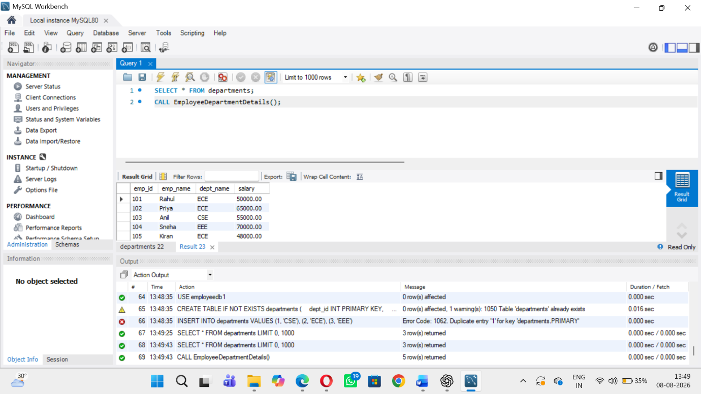
6 Create a procedure to display departments whose average salary is greater than 55000
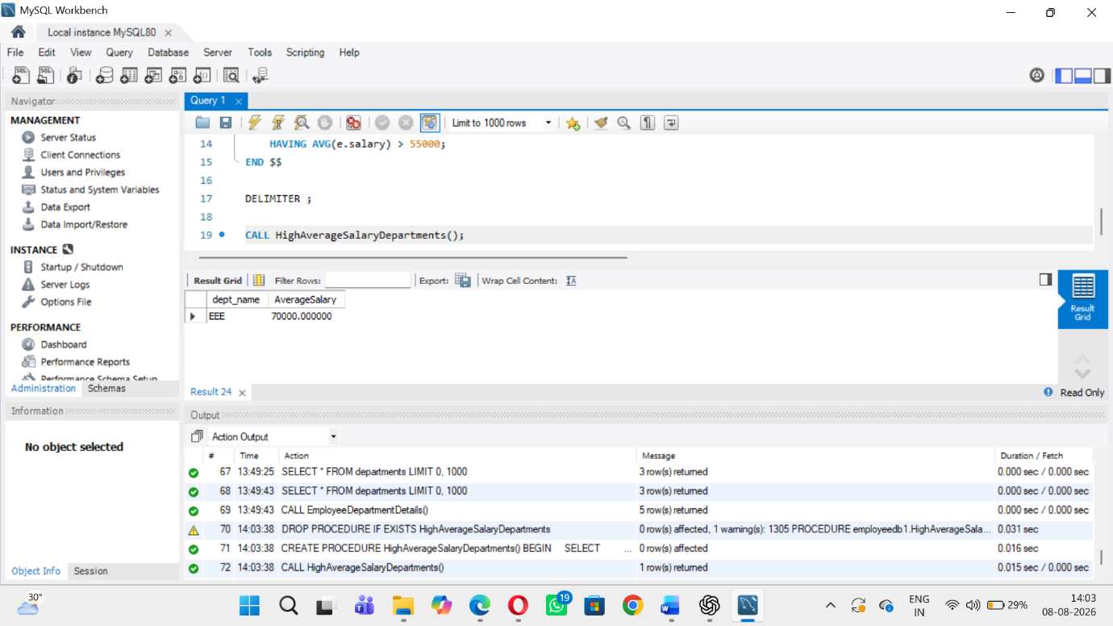
7 Create a procedure using IF...ELSE to classify salary as High, Medium or Low.
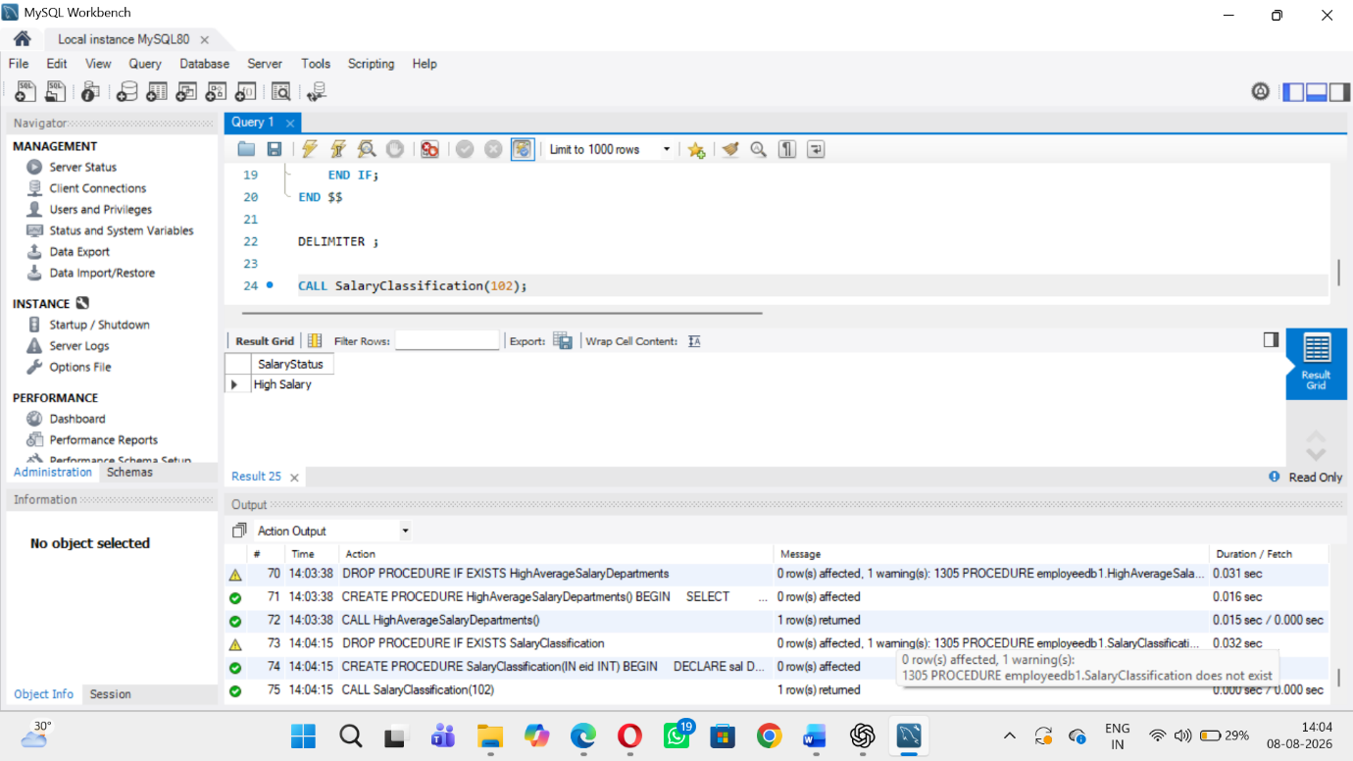
8 Create a procedure that accepts a department ID and returns its average salary.
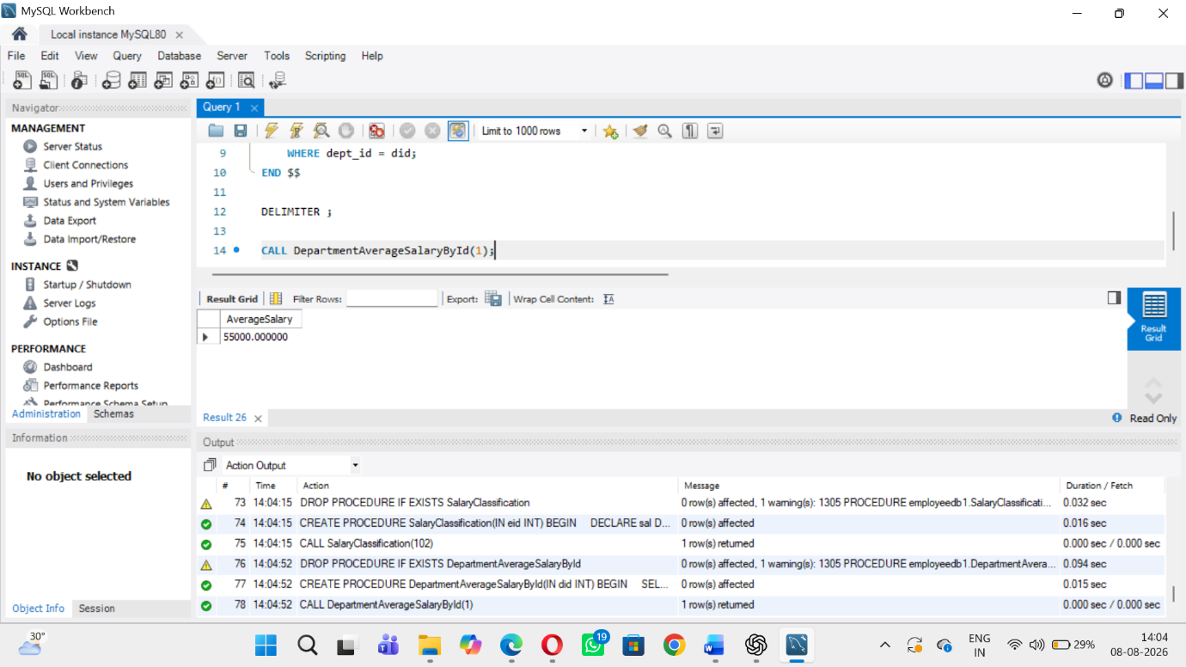
9 Create a procedure using INOUT to apply a bonus to an input salary.
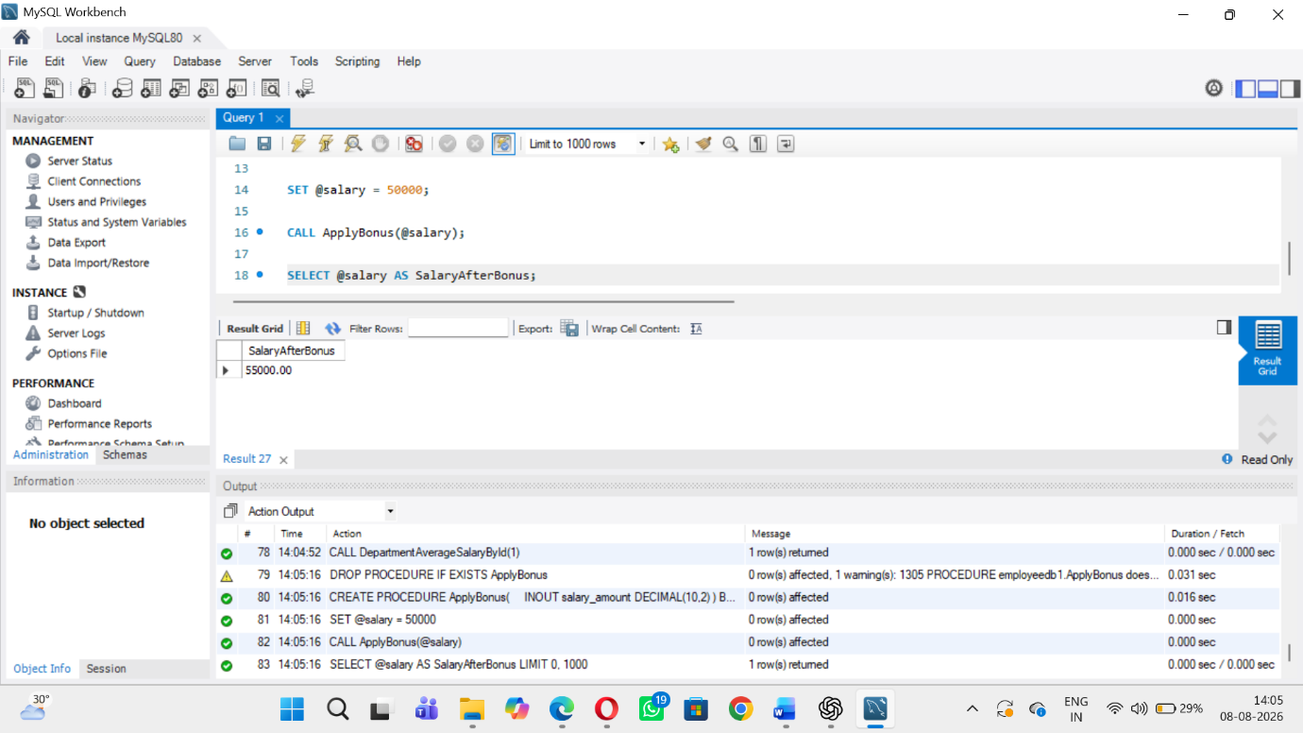
10 Create a procedure that performs two related updates inside a transaction